Name: DIVYANSH DAHIMA

Roll no.: 23I4021

**Lab Assignment 2: Study and Understand Ubuntu Commands**

**Part 1: Outputs of the Following Commands**

1. pwd

It prints the current working directory.

Output:

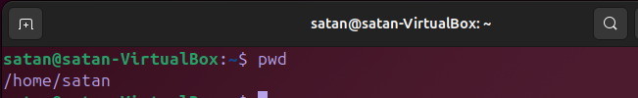

1. cd

Changes the current directory.

Output:

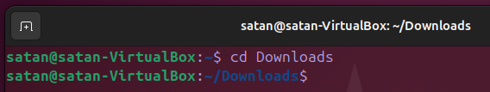

1. ls

Lists files and directories in the current directory.

Output:

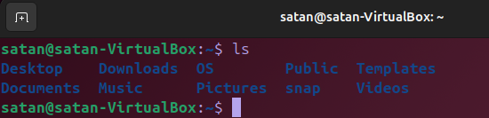

1. mkdir

Creates a new directory.

Output:



1. rm

Removes files or directories.

Output:

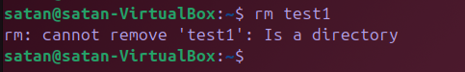

1. touch

Creates an empty file or updates the timestamp of an existing file.

Output:



1. hostname

Displays the system's hostname.

Output:



1. cat

Displays the contents of a file.

Output:



1. chmod

Changes file permissions.

Output:

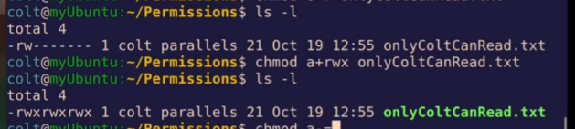

1. echo

Displays a line of text or a variable's value.

Output:



1. grep

Searches for a pattern in a file.

Output:

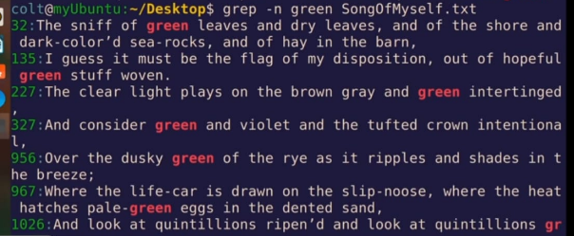

1. fgrep

Searches for fixed strings in a file.

Output:

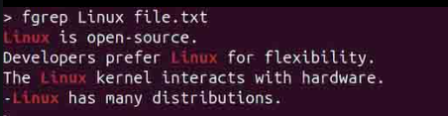

1. mv

Moves or renames files/directories.

Output:

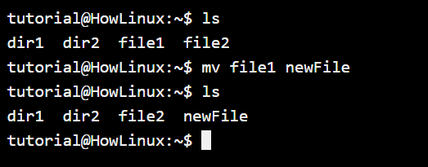

1. cp

Copies files/directories.

Output:

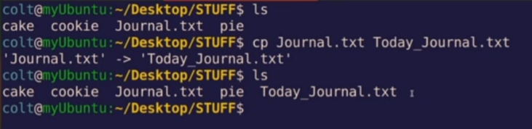

1. more

Displays file content one screen at a time.

Output:

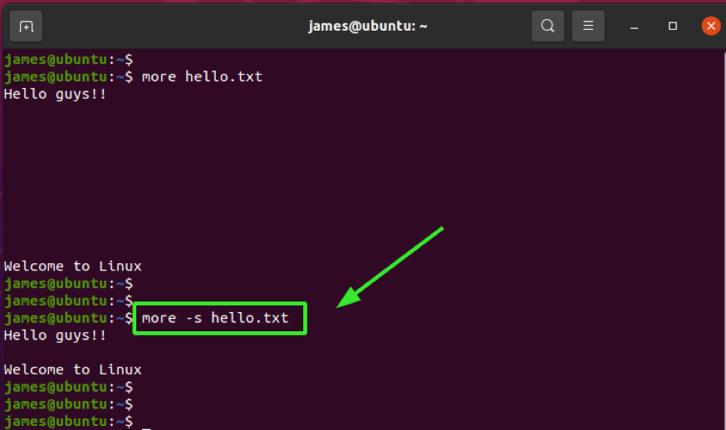

1. less

Displays file content with backward navigation.

Output:

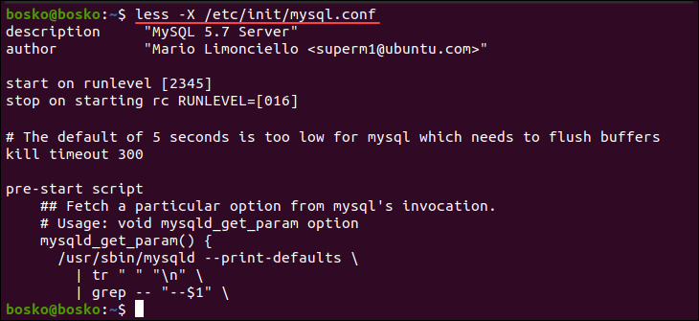

1. wc

Counts lines, words, and characters in a file.

Output:



1. awk

Processes and analyzes text files.

Output:

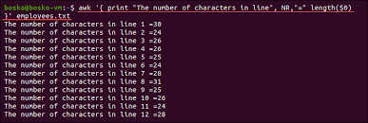

1. sed

Stream editor for filtering and transforming text.

Output:

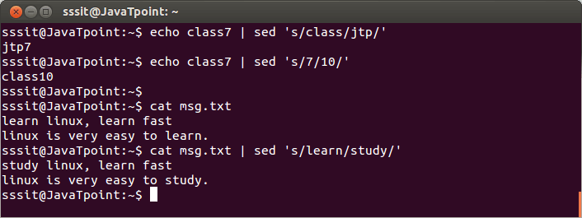

1. tail

Displays the last part of a file.

Output:

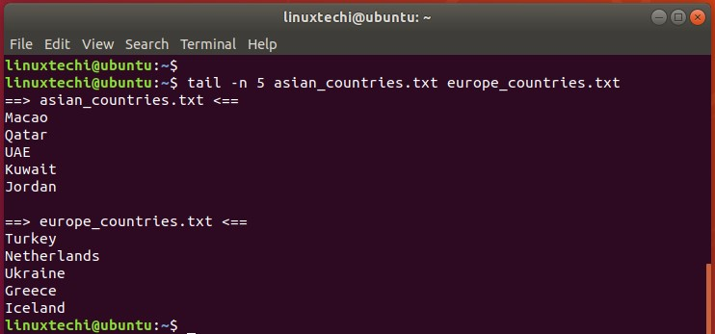

**Part 2: Answers to the Following Questions**

1. How to navigate to a Specific Directory?

Ans- We use the cd command followed with the specific location.

Example:

cd /path/to/directory

1. How to see detailed information about files and directories using ls?

Ans-

ls -l

1. How to create multiple directories in Linux using `mkdir` command?

Ans-

mkdir dir1 dir2 dir3

1. How to remove multiple files at once with rm?

Ans-

rm file1 file2 file3

or for files with wildcards

rm *.txt

1. Can rm be used to delete directories?

Ans- Yes, to delete directories:

rm -r directory_name

1. How Do You Copy Files and Directories in Linux?

Ans-

cp source_file destination_file

cp -r source_directory destination_directory

1. How to Rename a file in Linux Using mv Command

Ans- Using

mv old_filename new_filename

1. How to Move Multiple files in Linux Using mv Command

Ans-

mv file1 file2 file3 /destination/directory/

1. How to Create Multiple Empty Files by Using Touch Command in Linux

Ans-

touch file1 file2 file3

1. How to View the Content of Multiple Files in Linux

Ans-

cat file1 file2

1. How to Create a file and add content in Linux Using `cat` Command

Ans- To create a file and add content, we use:

cat > filename

then type the content and save the file.

1. How to Append the Contents of One File to the End of Another File using cat command

Ans-

cat source_file >> destination_file

1. How to use cat command if the file has a lot of content and can’t fit in the terminal.

Ans-

cat filename | less

1. How to Merge Contents of Multiple Files Using `cat` Command

Ans-

cat file1 file2 > merged_file

1. How to use cat Command to Append to an Existing File

Ans-

cat >> filename

1. What is “chmod 777 “, “chmod 755” and “chmod +x “or “chmod a+x”?

Ans- chmod 777 file - Full permissions for all.

chmod 755 file - Full permissions for the owner, read & execute for others.

chmod +x file - Adds execute permission.

chmod a+x file - Adds execute permission for all users.

1. How to find the number of lines that matches the given string/pattern

Ans-

grep -c "pattern" filename

1. How to display the files that contains the given string/pattern.

Ans-

grep -l "pattern" *

1. How to show the line number of file with the line matched.

Ans-

grep -n "pattern" filename

1. How to match the lines that start with a string using grep

Ans-

grep "^string" filename

1. Can the ‘sort’ command be used to sort files in descending order by default?

Ans- No, sort sorts in ascending order by default. For descending, we use:

sort -r filename

1. How can I sort a file based on a specific column using the ‘sort’ command?

Ans-

sort -k2 filename